Python Queue: FIFO, LIFO Example

A queue is just like a list that is used to hold data. There are two types of queues.

1. **FIFO**

stands for “First in First out”. **Queue()** function is used for FIFO.

1. **LIFO**

stands for “Last in First out”. **LifoQueue()** function is for LIFO.

The FIFO queue can be quickly compared with the real-world instance of the line of people staying in a line at the airport, the individual standing foremost will get the ticket first, pursued by the next person, and so on. The same logic goes for the FIFO queue data structure too.

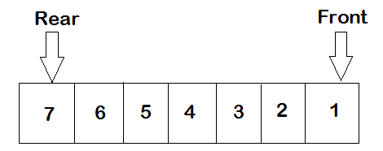

Take a look at the above example. In the above queue, there are two points front and rear. The item can only be taken out from the queue either from the front or rear side. You can’t take 4 out of the queue.

## **Functions available inside Queue and LifoQueue.**

* **put(item):** This function will put the item inside the queue.
* **get():** l returns the item from the queue.
* **empty():** returns true if empty else false.
* **qsize():** returns the size of the queue.
* **full():** returns true if the queue is full, otherwise false.

## FIFO

For using FIFO queue you need to import it using the code given below.

|  |
| --- |
| import queue |

### **Add and item in a queue**

Put function is used to put elements in the queue.

|  |
| --- |
| import queue queue1 = queue.Queue(5) queue1.put(11) queue1.put(12) queue1.put(13) queue1.put(14) queue1.put(15) |

## 

## 

## 

## Getting elements from Queue

Get function is used to get elements from the queue.

|  |
| --- |
| import queue queue1 = queue.Queue(5) queue1.put(11) queue1.put(12) queue1.put(13) queue1.put(14) queue1.put(15) for i in range(5):  print(queue1.get()) |

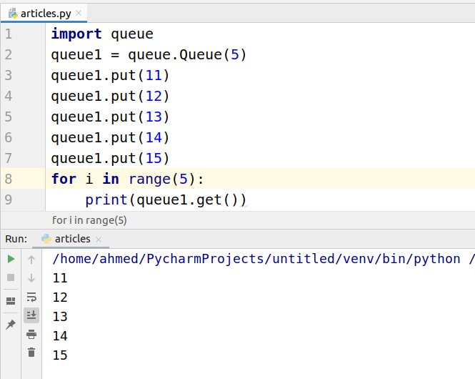

## Length of queue

To find the queue size we need to use the qsize function.

|  |
| --- |
| import queue queue1 = queue.Queue(5) queue1.put(11) queue1.put(12) queue1.put(13) queue1.put(14) queue1.put(15) print(queue1.qsize()) |

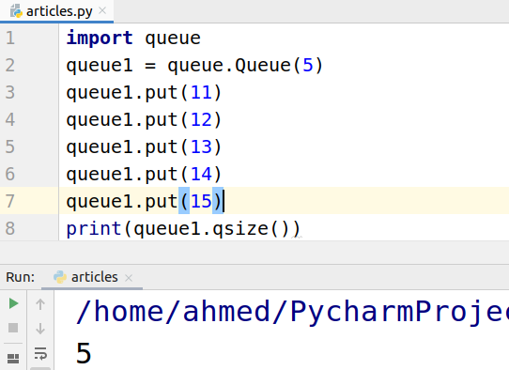

## LIFO

The following code is used to create a LIFO queue.

|  |
| --- |
| import queue queue1 = queue.LifoQueue(5) |

### **Add and item in a LIFO queue**

Same as the FIFO we need to use Put function to put elements in the queue.

|  |
| --- |
| import queue queue1 = queue.LifoQueue(5) queue1.put(11) queue1.put(12) queue1.put(13) queue1.put(14) queue1.put(15) |

## Getting elements from LIFO Queue

Get function is used to get elements from the queue.

|  |
| --- |
| import queue queue1 = queue.LifoQueue(5) queue1.put(11) queue1.put(12) queue1.put(13) queue1.put(14) queue1.put(15) for i in range(5):  print(queue1.get()) |

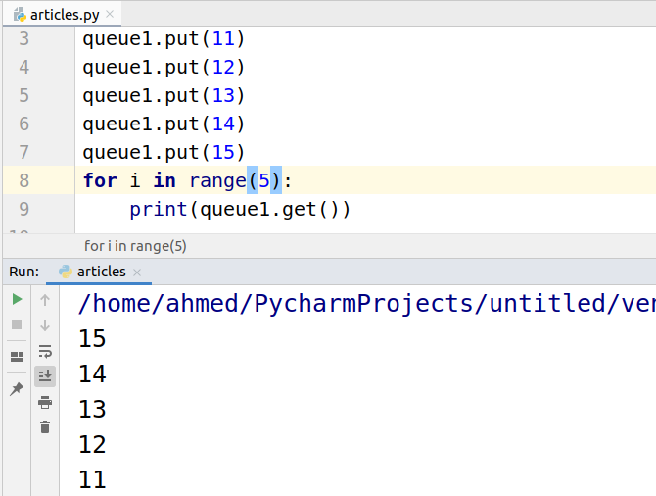

## Length of queue

To find the queue size we need to use the qsize function.

|  |
| --- |
| import queue queue1 = queue.LifoQueue(5) queue1.put(11) queue1.put(12) queue1.put(13) queue1.put(14) queue1.put(15) print(queue1.qsize()) |

